ENGLISH | MATHEMATICS |  |  | SCIENCE |  |  | COMPUTING
Narrative: Story writing based on a familiar story ‘The Night Pirates’  Non-fiction: Recounts and instructions ‘How to become a pirate’ | Number and place value- value of digits in HTO, more and less, using pictorial representations and objects.  Addition and subtraction- number bonds to 20 including subtraction facts, solve one step problems, add and subtract one digit and two-digit numbers to 20 |  |  | Seasonal changes  Children will explore the signs of summer in the first few weeks of term, and then go on an autumn walk nearer half term to notice seasonal changes happening.  Children will discuss spring and summer and how the seasons change from one to another. |  |  | Learning about online safety.  Accessing a range of learning-based games for Maths and English.  Using programable Bee Bots and skills learnt to enable them to find treasure on maps.
HISTORY |  | Pirates - Land Ahoy!  In this topic we will be finding out about Pirates in Term 1. The children will learn about  pirates from the past, how to become a pirate and how to navigate the land around them.  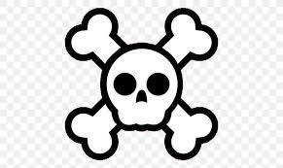  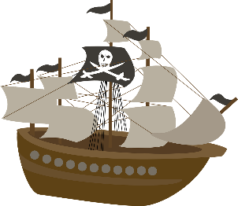 |  |  | GEOGRAPHY
To find out about famous pirates (Blackbeard and Calico Jack) and their lives. To look at their impact on history. Compare with present day pirates. |  |  |  |  | To be able to use maps and globes to understand the world around them.  To link in compasses to direction and location.  To use geographical language and to describe the location and routes on a map.  To explore our school grounds and draw a simple map of the area.  To understand that the UK is an island and link this to drawing reassure islands and treasure maps.
PHYSICAL EDUCATION | ART |  | MUSIC | PSHE/ Jigsaw/Values |  | RE
Multi/Ball Skills: using a range of basic skills including throwing, catching, team games  Dance: using movement and posture to create a simple dance routine to music | Using and developing sketching and drawing skills to:  Draw simple treasure maps on aged paper.  Draw self-portraits and giving ourselves pirate features. |  | Sea Shanties Learning a range of songs linked to skills of listening and appraisal (using specific musical vocabulary in describing music).  Use of simple percussion instruments to accompany songs. | Being Me. How we are all unique and all have special qualities to work and play together.  Values: Responsibly and Cooperation  Children will learn key skills to support them in their new class linked to gaining more responsibility for their own actions and organisation now, as well as developing their cooperation within friendships and teamwork learning. |  | Introduction to Christianity  Harvest

