English | Maths | Science | Computing
Text – ‘The curse of the Maya’ by Johnny Pearce and Andy Loneragan  Fiction – Mystery and suspense narrative  Non – fiction – Discursive texts  Reading – Vocabulary, inference, prediction, explain and summarise.  Grammar – hyphens and using hyphens to avoid ambiguity.  Direct and reported speech  Adverbials for cohesion. | Geometry – position and direction  Describe positions on the full coordinate grid (all 4 quadrants)  Draw and translate simple shapes on the coordinate plane, and reflect them in the axes.  Algebra  Use simple formulae and generate linear number sequences.  Express missing number problems algebraically. | Light  Use the idea that light travels in straight lines to explain that objects are seen because they give out or reflect light into the eye.  Electricity  Associate the brightness of a lamp or the volume of a buzzer with the number and voltage of cells used.  Use recognised symbols when representing a simple circuit. | Use search technologies effectively, appreciate how results are selected and ranked.  Use technology safely, respectfully and responsibly.  Understand computer networks including the internet; how they can provide multiple services, such as the world wide web; and the opportunities they offer for communication and collaboration.
History | 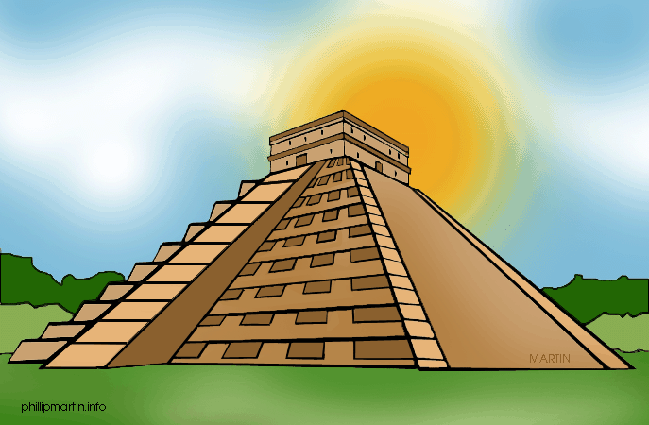  The Maya Civilisation |  | Geography
Maya civilisation  Understand the timeline and chronology of the Maya civilisation.  Explore their traditions and culture.  Evaluate the impact of their inventions and developments.  Evaluate primary and secondary sources. |  |  | Maya civilisation  Identify and locate continents and key countries in the world.  Understand the location of the Maya civilisation.  Identify physical and human features of Mexico and Central America.
PE | Art / Technology | Music | PSHCE
Tennis  Serving and technique  Footwork  Athletics  Develop flexibility, strength, technique, control and balance | Mayan masks  Mayan Artefacts  Bonampak Murals  Mayan Temples  Ceramics and clay | Ukulele  Play musical instruments with increasing accuracy, fluency, control and expression.  Use and understand staff and other musical notations. | Jigsaw term 5  Relationships – building healthy positive relationships
RE  Freedom and justice – what this means to different religions. |  | French  ‘My home’ and ‘The Olympics’

