ENGLISH | MATHEMATICS |  |  | SCIENCE |  |  | COMPUTING
Fiction: “The Queens Hat” by Steve Antony – losing tale  Non-fiction: Recount  Reading: “Prince Cinders” by Babette Cole and  “The Smallest Girl in the Class” by Justin Roberts | Addition and subtraction- number bonds to 10 including subtraction facts, solve one step problems, add and subtract one digit and two-digit numbers to 10  Shape – 2D and 3D shapes |  |  | Everyday Materials  Learning about the main materials that objects are made from and their properties. Using experiments to investigate what material best suits a particular purpose. |  |  | Creating media with digital painting
HISTORY |  | Kings and Queens  In this topic in Term 2 we will be finding out about Kings and Queens. We will look at the Kings and Queens through the ages as well as looking into the life of Queen Elizabeth II and our current Monarch, King Charles.  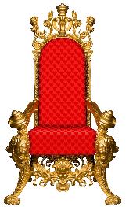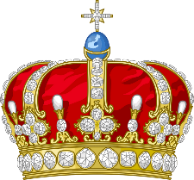 |  |  |  | GEOGRAPHY
To find out about the Kings and Queens of our past including Queen Elizabeth I and Queen Victoria, as well as looking at the life of Queen Elizabeth II and our new Monarch King Charles. We will compare the present day monarch with monarchs of the past. |  |  |  |  |  | Research famous destinations in our capital city London. Plot the route the ‘Queens Hat’ made through London on a map. If you were to recreate the journey, how would you travel to each location? How long might each step take?
PHYSICAL EDUCATION | ART |  | MUSIC |  | PSHE/ Jigsaw |  |  | RE
Football: learning and practicing the skills need to play a football match.  Dance: using movement and posture to create simple dance routines. | Drawing:  To use a variety of drawing tools, learn different drawing techniques and use lines, patterns and texture to create drawings. |  | Charango – ‘Rhythm in the way we walk’  The National Anthem  Christmas songs |  | Celebrating Difference. Respect for similarity and difference. Anti-bullying and being unique. |  |  | Christianity – Advent and Christmas and their importance in the religion of Christianity.

